**Delivery Logistics Data Ingestion Kafka-MongoDB**

**Objective:**

Developed a Python-based application that integrates Kafka and MongoDB to process logistics data. The application involved a Kafka producer and consumer, data serialization/deserialization with Avro, and data ingestion into MongoDB.

**Tools Used:**

1. Python3
2. Confluent Kafka
3. MongoDB Atlas
4. MongoDB Compass

**Files Attached:**

1. delivery_trip_truck_data.csv – The csv raw data used to push to the kafka topic
2. logistics_data_producer.py – Python producer script
3. logistics_data_consumer.py – Python consumer script

**Process and File Descriptions:**

1. Created a kafka topic called ‘logistics_data’ with 6 partitions and I made sure to save the API keys for the producer. I also created an appropriate schema value and key to prepare the kafka topic for data ingestion/retrieval looking at the delivery_trip_truck_data.csv file. I especially made sure to handle the ‘Nan’ values by replacing them with the string ‘unknown value’ if the field is string type.

logistics csv:

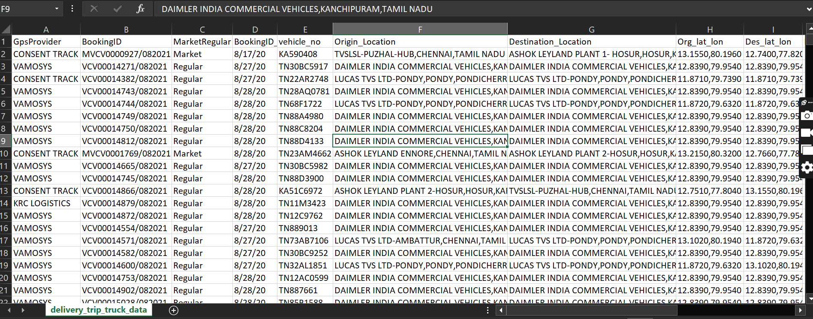

avro schema serializer format:

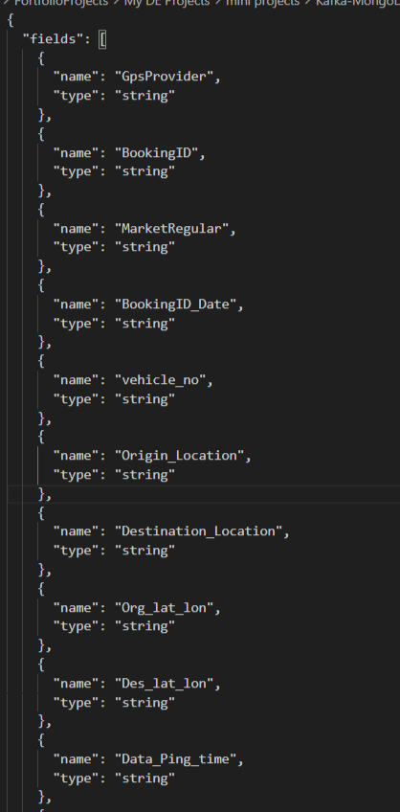

2. I created a producer script called “logistics_data_producer.py” that produces the data to the afore- mentioned Kafka topic. The script also serializes the data into Avro format and uses GPSProvider as the key.

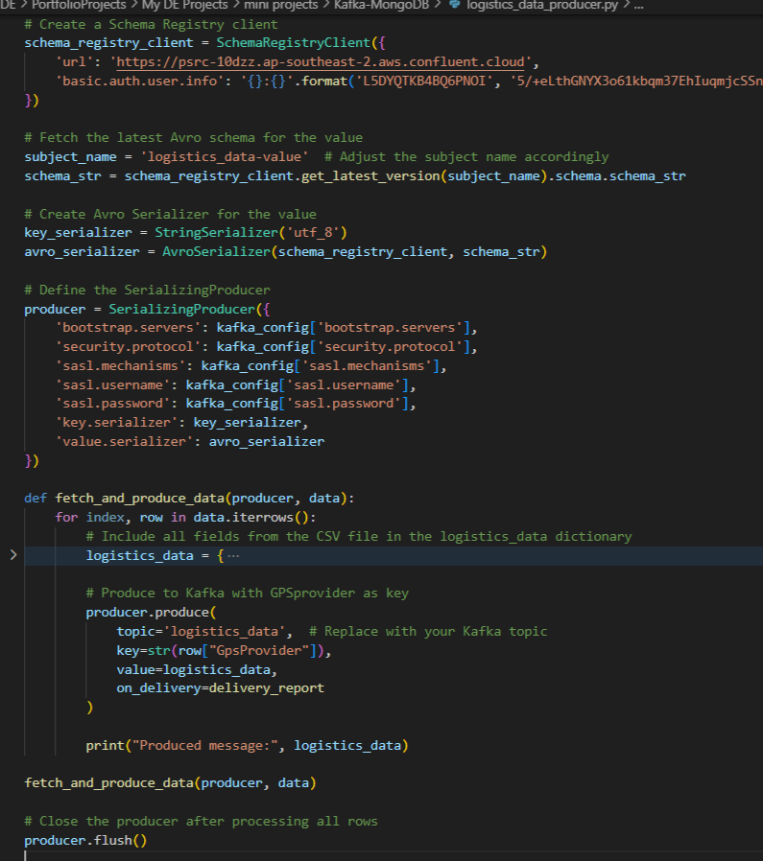

3. The below image shows the producer fetching data. It also sends out a message saying that the record value has been successfully produced in a particular partition.

messages published to confluent kafka topic:

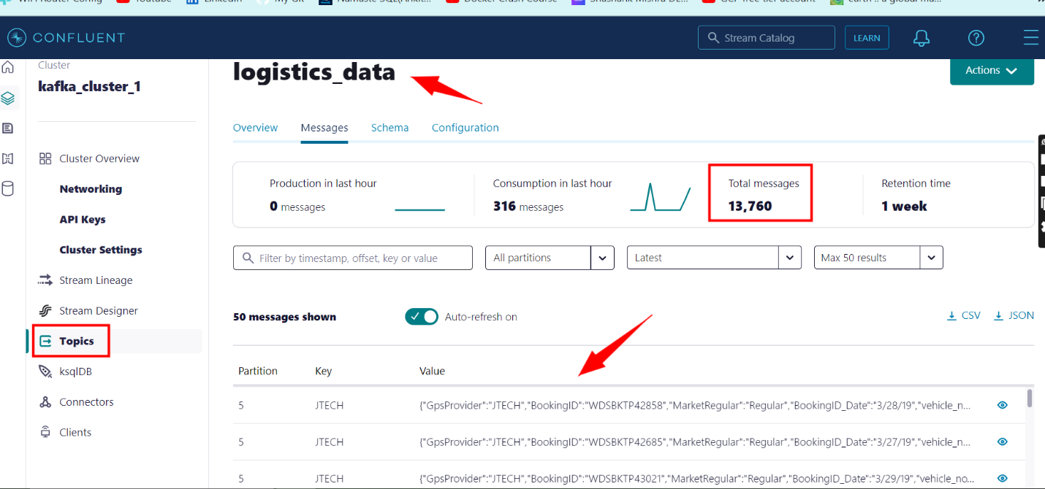

4.Created a mongodb database called ‘gds_db’ and created an empty collection called ‘logistics_data’ so that data can be stored once a consumer script can be run.

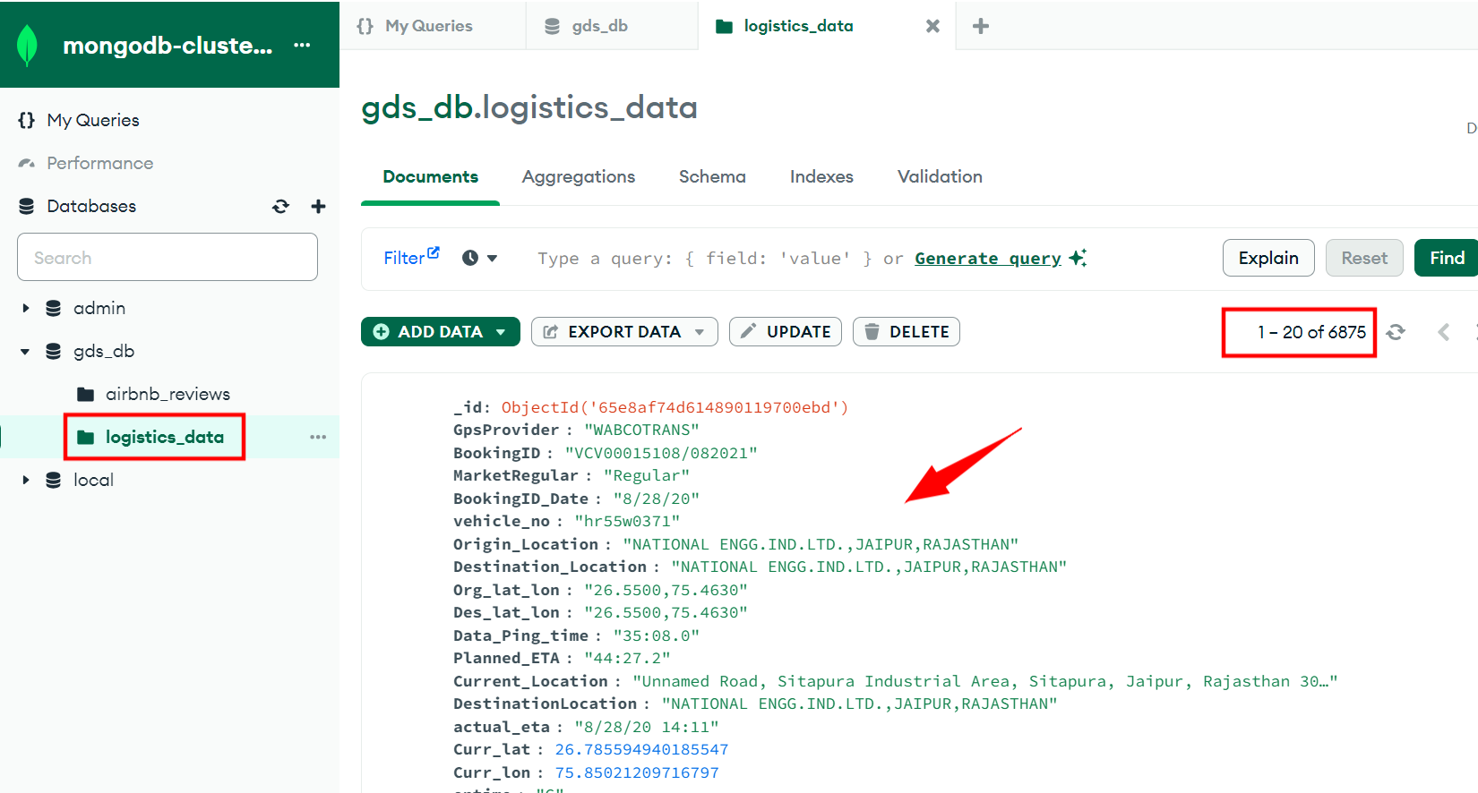

5. then created a consumer script called “logistics_data_consumer.py” that deserializes the avro data back into a python object. I then implemented data validation checks in the code to make sure that it accounts for null values and correct data types checks. Before pushing the data into the logistics_data collection that was created in the gdb_db mongodb database, I made sure that there are no duplicate records pushed when the consumer runs.

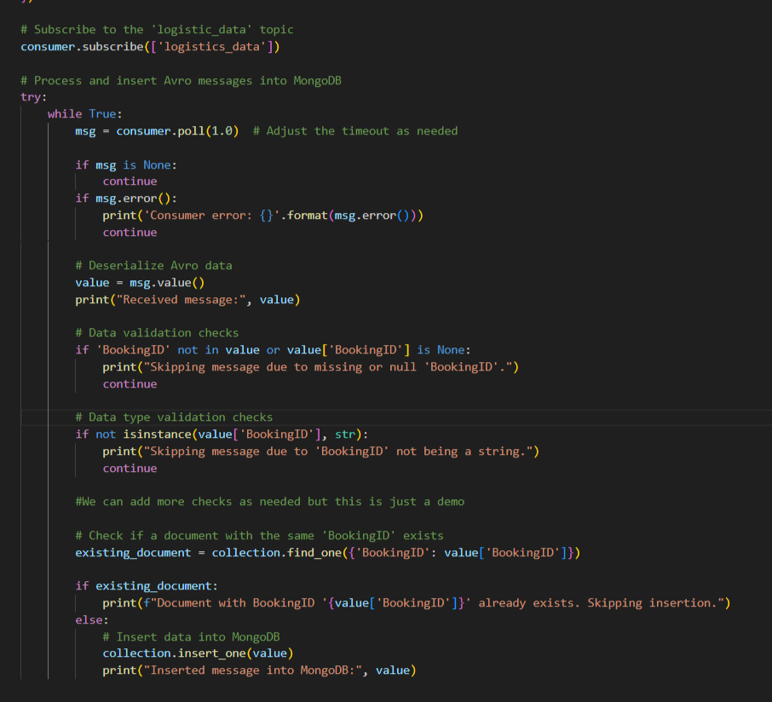

6.We can also check the data using Mongodb Compass:

